**Movieteca**

Software Design Document

Name (s): Radulescu Alexandru, Preda Radu-Alexandru,

Sacuianu Ionut-Alexandru, Simon Jozsef-Gabriel

Lab Section: Software Engineering

Date: (03/23/2020)

**TABLE OF CONTENTS**

|  |  |  |  |
| --- | --- | --- | --- |
| **1.** | 1.1 | **INTRODUCTION**  Purpose | **2**  2 |
|  | 1.2 | Scope | 2 |
|  | 1.3 | Overview | 2 |
|  | 1.4 | Reference Material | 2 |
|  | 1.5 | Definitions and Acronyms | 2 |
| **2.** |  | **SYSTEM OVERVIEW** | **2** |
| **3.** |  | **SYSTEM ARCHITECTURE** | **2** |
|  | 3.1 | Architectural Design | 2 |
|  | 3.2 | Decomposition Description | 3 |
|  | 3.3 | Design Rationale | 3 |
| **4.** | 4.1 | **DATA DESIGN**  Data Description | **3**  3 |
|  | 4.2 | Data Dictionary | 3 |
| **5.** |  | **COMPONENT DESIGN** | **3** |
| **6.** |  | **HUMAN INTERFACE DESIGN** | **4** |
|  | 6.1 | Overview of User Interface | 4 |
|  | 6.2 | Screen Images | 4 |
|  | 6.3 | Screen Objects and Actions | 4 |
| **7.** |  | **REQUIREMENTS MATRIX** | **4** |
| **8.** |  | **APPENDICES** | **4** |

**1. INTRODUCTION**

**1.1 Purpose**

Identify the purpose of this SDD and its intended audience. (e.g. “This software design document describes the architecture and system design of XX. ….”).

**1.2 Scope**

Provide a description and scope of the software and explain the goals, objectives and benefits of your project. This will provide the basis for the brief description of your product.

**1.3 Overview**

Provide an overview of this document and its organization.

**1.4 Reference Material**

List any documents, if any, which were used as sources of information for the test plan.

**1.5 Definitions and Acronyms**

Provide definitions of all terms, acronyms, and abbreviations that might exist to properly interpret the SDD. These definitions should be items used in the SDD that are most likely not known to the audience.

**2. SYSTEM OVERVIEW**

Give a general description of the functionality, context and design of your project. Provide any background information if necessary.

**3. SYSTEM ARCHITECTURE**

**3.1 Architectural Design**

Develop a modular program structure and explain the relationships between the modules to achieve the complete functionality of the system. This is a high level overview of h

responsibilities of the system were partitioned and then assigned to subsystems. Identify each high level subsystem and the roles or responsibilities assigned to it. Describe how these subsystems collaborate with each other in order to achieve the desired functionality. Don’t go into too much detail about the individual subsystems. The main purpose is to gain a general understanding of how and why the system was decomposed, and how the individual parts work together. Provide a diagram showing the major subsystems and data repositories and their interconnections. Describe the diagram if required.

**3.2 Decomposition Description**

Provide a decomposition of the subsystems in the architectural design. Supplement with text as needed. You may choose to give a functional description or an object­oriented description. For a functional description, put top­level data flow diagram (DFD) and structural decomposition diagrams. For an OO description, put subsystem model, object diagrams, generalization hierarchy diagram(s) (if any), aggregation hierarchy diagram(s) (if any), interface specifications, and sequence diagrams here.

**3.3 Design Rationale**

Discuss the rationale for selecting the architecture described in 3.1 including critical issues and trade/offs that were considered. You may discuss other architectures that were considered, provided that you explain why you didn’t choose them.

**4. DATA DESIGN**

**4.1 Data Description**

In our code files all the database tables are represented by models. These models are afterwards transformed into tables by a framework. We will use as data types: integer lists, integer variables, integer arrays, string lists and arrays, string variables. This will help us implement the functionalities for the queries, for example: log in, displaying the movies to users etc. The data structures are to be used in such ways as following tables at 4.2.

**4.2 Data Dictionary**

Alphabetically list the system entities or major data along with their types and descriptions. If you provided a functional description in Section 3.2, list all the functions and function parameters. If you provided an OO description, list the objects and its attributes, methods and method parameters.

ADMIN

|  |  |  |
| --- | --- | --- |
|  | Type | NULL |
| Username | Varchar(30) | - |
| Password | Varchar(30) | - |
| Email | Varchar(30) | - |

USER

|  |  |  |
| --- | --- | --- |
|  | Type | NULL |
| User Type | Varchar(30) | - |
| Username | Varchar(30) | - |
| Password | Varchar(30) | - |
| Email | Varchar(30) | - |
| Sex | Varchar(10) | - |
| Birthdate | date | - |
| Country | Varchar(30) | - |
| City | Varchar(30) | - |
| Phone number | Varchar(30) | - |

SINGLE MOVIE

|  |  |  |
| --- | --- | --- |
|  | Type | NULL |
| Movie Name | Varchar(30) | - |
| Owned by | Varchar(30) | - |
| Sell price | Numeric | - |
| Rent price | Numeric | - |
| On stock | Numeric | - |

MOVIES LIST PROVIDER

|  |  |  |
| --- | --- | --- |
|  | Type | NULL |
| RENTED OR SOLD | Varhcar(30) | - |
| Moviename | Varchar(30) | - |
| Sold/Rented to | Varchar(30) | - |
| Price | Numeric | - |
| Date | Date | - |

MOVIE LIST CUSTOMER

|  |  |  |
| --- | --- | --- |
|  | Type | NULL |
| RENTED OR SOLD | Varhcar(30) | - |
| Moviename | Varchar(30) | - |
| Sold/Rented FROM | Varchar(30) | - |
| Price | Numeric | - |
| Date | Date | - |

**5. COMPONENT DESIGN**

In this section, we take a closer look at what each component does in a more systematic way. If you gave a functional description in section 3.2, provide a summary of your algorithm for each function listed in 3.2 in procedural description language (PDL) or pseudocode. If you gave an OO description, summarize each object member function for all the objects listed in 3.2 in PDL or pseudocode. Describe any local data when necessary.

**6. HUMAN INTERFACE DESIGN**

**6.1 Overview of User Interface**

Describe the functionality of the system from the user’s perspective. Explain how the user will be able to use your system to complete all the expected features and the feedback information that will be displayed for the user.

**6.2 Screen Images**

**HOME PAGE**

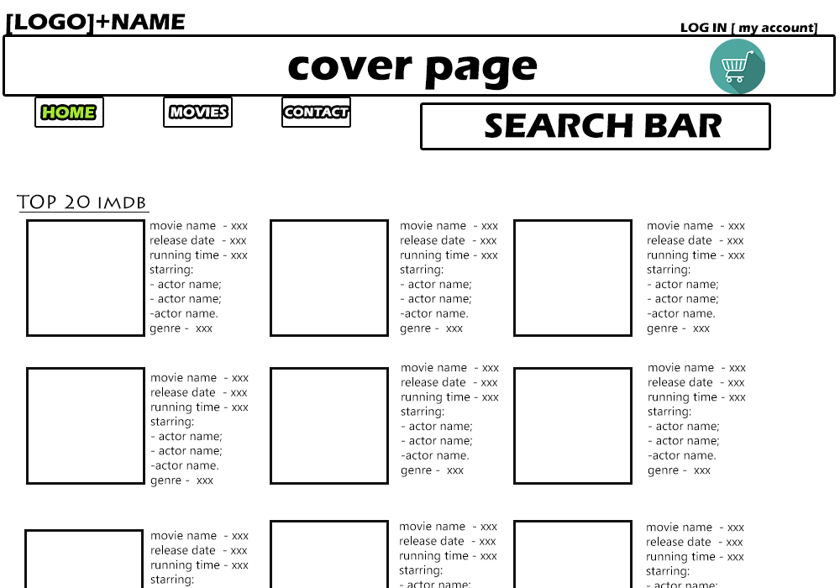

**MOVIE PAGE**

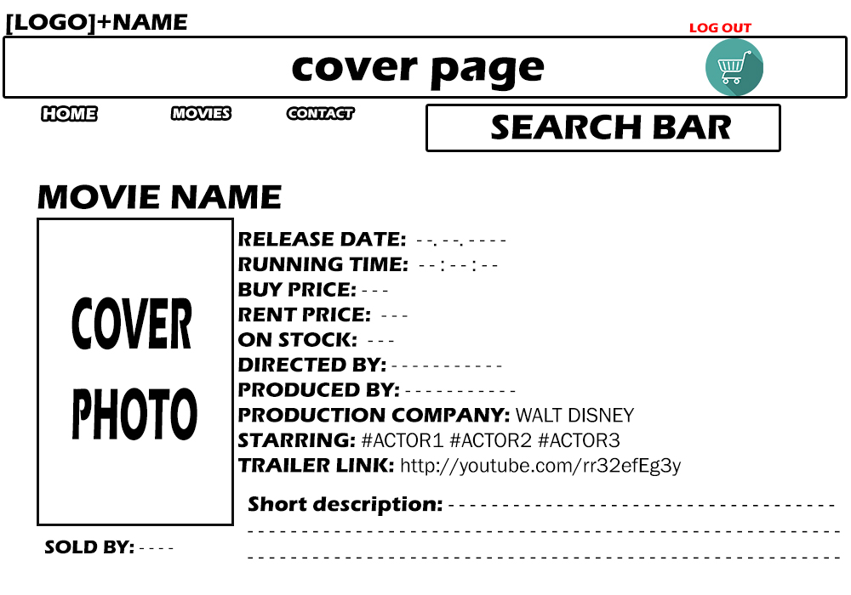 **MY ACCOUNT**

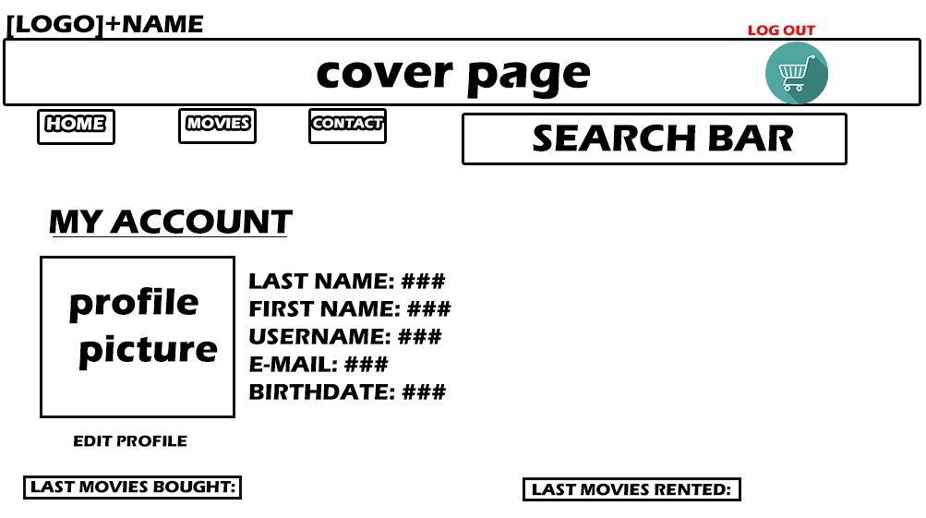

**LOG IN**

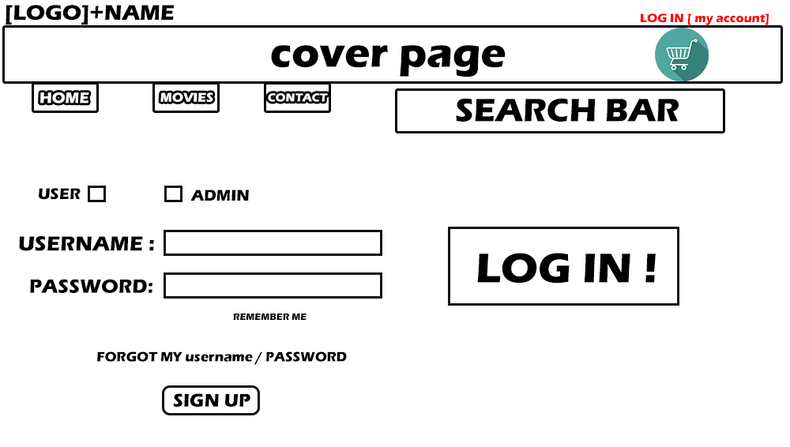

**CONTACT**

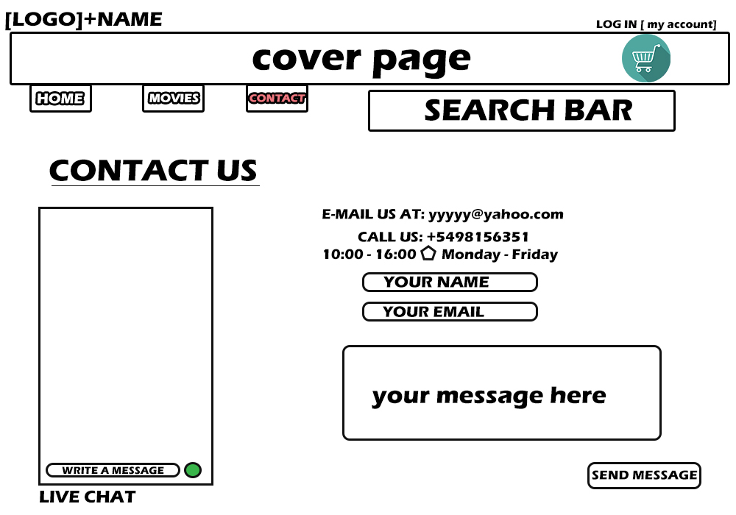

**6.3 Screen Objects and Actions**

A discussion of screen objects and actions associated with those objects.

Our web application consists in a few interface objects and each of them has a meaningful purpose. For example we have:

Input Objects: Text field ( Search bar, Log In, Register, Radiobuttons, Add to Cart Button ),

LIVE CHAT

Information Objects: Photos, Descriptions, Account details, LIVE CHAT

Navigation Objects: Movies List, Rent / Bought List, Sold / Rented List ( slide down)  
 Top buttons ( HOME / MOVIES / CONTACT / MY ACCOUNT )

**7. REQUIREMENTS MATRIX**

Provide a cross­reference that traces components and data structures to the requirements in yourSRS document.Use a tabular format to show which system components satisfy each of the functional requirements from the SRS. Refer to the functional requirements by the numbers/codes that you gave them in the SRS.

**8. APPENDICES**

*This section is optional.*

Appendices may be included, either directly or by reference, to provide supporting details that could aid in the understanding of the Software Design Document.